 | Job Description & Person Specification | August 2026

Role: Fundraising Executive - Giving Campaigns & Products | Department: Audiences & Support
Reports to: Fundraising Manager - Giving Campaigns & Products | Pay Grade: Grade 6 - £38,967 Per Annum
Location: Broadstone Building, 50 South Gyle Crescent, Edinburgh, EH12 9LD / Hybrid | Type of Contract: Full-Time, 40 Hours Per Week. Fixed-Term, 12 Month Contract

ABOUT US

The National Trust for Scotland is Scotland’s leading conservation and membership charity dedicated to protecting and promoting Scotland's natural, cultural and built heritage. We care for historic places, landscapes and collections across the country so they can be enjoyed for generations to come.

The National Trust for Scotland is a fundraising charity with a successful and high performing fundraising team. Investment and organisational commitment since 2019/20 have driven strong and sustained growth, with the team consistently exceeding targets and generating an average of £10 million annually.

JOB PURPOSE

The wider purpose of the role is to help drive the National Trust for Scotland’s ability to conserve Scotland’s built, natural and cultural heritage in our care. Specific to this role, you will work with the Fundraising Manager, Giving Campaigns & Products, to grow support and income from individual giving programmes and fundraising products. This is a varied and complex role through which you will support the strategic leadership of mass market and mid-level fundraising, growing our portfolio of donors and prospects and empowering our property teams and supporter groups to raise funds.

Coordinating and supporting individual giving programmes and fundraising products such as the Founders’ Circle, regular giving programme, Scottish Heritage Lottery and Dedicate a Tree, you will contribute to achieving an income target of £800,000 and above per year, ensuring vital funds and growing awareness for our charity’s work. A team player, you will work as a key member of the Giving Campaigns & Products team whilst supporting the wider Fundraising & Philanthropy team.

This role supports and drives our highest profile, mass market fundraising activity and crucial pipeline development for Fundraising & Philanthropy income streams, requiring skilled multi-tasking, creativity and a laser focus on continuous improvement and results.

KEY RESPONSIBILITIES AND ACCOUNTABILITIES

1. Individual Giving, Campaigns & Products
- Coordinate and deliver fundraising campaigns, appeals and products across multiple channels.
- Support the delivery of regular giving, online giving, Founders' Circle, Scottish Heritage Lottery and Dedicate a Tree.
- Contribute to supporter acquisition, retention and income growth activity.

2. Supporter Journeys & Stewardship
- Deliver supporter communications, stewardship activity and donor engagement initiatives.
- Support stewardship events and fundraising communications.
- Help ensure supporters receive excellent experiences and appropriate recognition.

3. Audience Insight, Data & Performance
- Use audience data, segmentation and campaign reporting to support decision making and continuous improvement.
- Monitor campaign performance and provide analysis and recommendations.
- Maintain accurate records and reporting information.

4. Members' Centres, Friends Groups & Property Fundraising
- Support fundraising activity undertaken by Members' Centres, Friends Groups and Trust properties.
- Develop and maintain fundraising materials, guidance and toolkits.
- Coordinate communications and stewardship activity for supporter groups and place-based fundraising initiatives.

5. Stakeholder Management & Collaboration
- Work collaboratively with Marketing, Content, Fundraising Operations, Supporter Care and other internal teams.
- Coordinate activity with agencies, suppliers and third parties where required.
- Build positive working relationships across the organisation.

6. Financial & Operational Management
- Support management of campaign expenditure and income reporting.
- Ensure fundraising administration, fulfilment and operational activity are delivered accurately and efficiently.

7. Compliance & Risk Management
- Ensure fundraising activities are delivered in accordance with regulation, organisational procedures and best practice.
- Support accurate record keeping and compliance monitoring.

8. Innovation & Growth
- Contribute ideas for new fundraising campaigns, products and supporter engagement activity.
- Support testing and improvement of fundraising approaches and processes.

REQUIRED QUALIFICATIONS, SKILLS, EXPERIENCE & KNOWLEDGE

Qualifications
Essential
- None

Desirable
- Project Management qualification e.g. APM Project Fundamentals
- Process Improvement qualification e.g. Six Sigma Yellow Belt
- Excel Associate Certification

Skills, Experience & Knowledge
Essential

Individual Giving, Campaigns & Products
- Experience supporting or delivering fundraising campaigns, appeals or fundraising products.
- Understanding of donor acquisition, retention and supporter engagement principles.

Supporter Journeys & Stewardship
- Experience supporting customer, supporter or donor communications and stewardship activity.

Audience Insight, Data & Performance
- Experience using data, reporting or audience insight to evaluate performance and support decision making.

Members' Centres, Friends Groups & Property Fundraising
- Experience working collaboratively with volunteers, supporter groups or internal stakeholders to deliver engagement or fundraising activities.

Stakeholder Management & Collaboration
- Strong interpersonal and communication skills with the ability to build effective working relationships.

Financial & Operational Management
- Strong organisational skills and attention to detail.
- Experience managing multiple projects and competing priorities.

Compliance & Risk Management
- Understanding of fundraising or marketing compliance requirements and willingness to maintain specialist knowledge.

Innovation & Growth
- Proactive approach to identifying improvements and opportunities.

Technical & Professional Skills
- Experience using CRM systems and Microsoft Office applications.
- Experience producing written content and fundraising communications.

Desirable
- Sector and organisational context: Experience of working in a fast-paced organisation with a national reach.
- Gaming and lottery products: experience of gaming products, such as lottery, raffle or prize draw activity.
- Travel: a current valid driving license for driving in the UK.

DIMENSIONS AND SCOPE OF JOB

Scale
- Working with the direction and support of the Giving Campaigns & Products Manager, you are responsible for individual giving and product fundraising. This is a varied and complex role with responsibility for delivering strategic leadership of mass market and mid-level fundraising with donors and prospects and empowering our places and supporter groups to raise funds.
- Contribute to income generation of +£800,000 per year, developing crucial pipelines for fundraising growth and supporting positive awareness-raising and reputation for our charity.
- In addition to five fundraising and stewardship appeals per year, you will support regular giving, fundraising products such as the Scottish Heritage Lottery and Dedicate a Tree, a mid-level giving programme, the Founders’ Circle giving circle, digital giving and place-based fundraising collateral.
- Support individual giving and fundraising product supporter journeys and stewardship, collaborating across Audiences & Support, to include impactful stewardship events and alignment with the Supporter Journeys Project.

People management
- Support and collaborate with team members in Fundraising & Philanthropy and across Audiences & Support, ensuring a coordinated and strategic approach to fundraising, marketing and communications.
- Establish and sustain strong working relationships with internal and external stakeholders, including design and media agencies and other third parties essential to the individual giving function.
- Work closely with colleagues across the Trust to ensure methods to inspire individual giving are managed and optimised.
- Occasional supervision of temporary administrative staff, interns and volunteers.

Finance management
- Supporting management of expenditure budget of circa £400K with income target of +£800,000 per year.
- Assisting with developing, reporting and analysing data-led individual giving activity.

Tools / equipment / systems
- Microsoft Dynamics
- Microsoft Planner
- Microsoft Teams
- Microsoft Word and Excel

Example key performance indicators and targets
- Income of +£800,000 per year
- % of members who are donors ​
- Average cash gift by giving levels ​
- Regular giver retention ​
- Appeal response rates ​
- % of donors generating Gift Aid ​
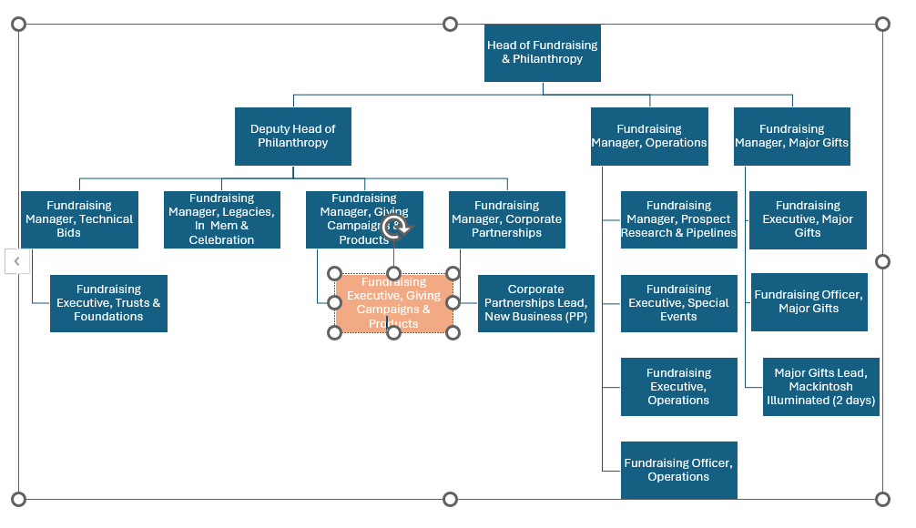

The Purpose, Context, Key Responsibilities, and Person Specification reflect the requirements of the job at the time of issue. The Trust reserves the right to amend these with appropriate consultation and/or request the post-holder to undertake any activities that it believes to be reasonable within the broad scope of the job or his/her general abilities.

HOW TO APPLY

Interested applicants should forward their Curriculum Vitae (CV) or an Application Form to the People Services Department (Applications) by email via workforus@nts.org.uk by Sunday 30th August 2026.

Please ensure your CV includes your full name and contact details, the CV file sent to us should be titled your first initial and surname. When submitting your CV please state the position and job location of the vacancy you are applying for in the subject title or body of your email: For example, "Fundraising Executive – Giving Campaigns & Products - NTS"

